|  |  |
| --- | --- |
| UFV_subbrand_Library | Creation of Persistent Links  **eHRAF** |

Persistent links direct students to specific full-text journal documents found in our research databases. These links are stable, and can be accessed from both on and off campus. These links could be used for e-reserves, electronic reading lists or incorporating into Brightspace and other online course resources.

1. Choose the item you want to link to. Click on Cite.

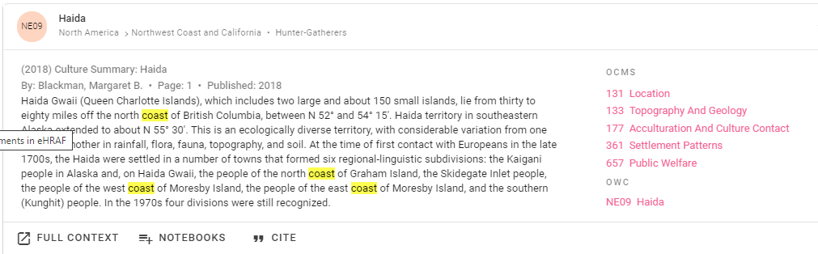

1. A pop-up window will open. Hit Copy. It will copy the whole citation

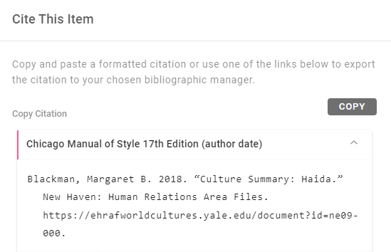

The persistent link will look like this:

1. A pop-up box will open, copy the URL.
2. Paste the citation and delete all but the url. (Remember to delete the period at the end of the url)

Blackman, Margaret B. 2018. “Culture Summary: Haida.” New Haven: Human Relations Area Files. <https://ehrafworldcultures.yale.edu/document?id=ne09-000>.

**Please note** that this URL does not include the UFV Library Open Athens proxy prefix, which is essential to providing off-campus access to the stable link.

1. To access the article off campus you need to add the following prefix to the existing url:

<https://go.openathens.net/redirector/ufv.ca?url=>

1. The finished URL will look like this:

<https://go.openathens.net/redirector/ufv.ca?url=https://ehrafworldcultures.yale.edu/document?id=ne09-000>

1. This link will take you to the publication information. Click on page 1 to see the document.

