|  |  |
| --- | --- |
| UFV_subbrand_Library | Creation of Persistent Links  **Early English Books Online** |

Persistent links direct students to specific full-text journal documents found in our research databases. These links are stable, and can be accessed from both on and off campus. These links could be used for e-reserves, electronic reading lists or incorporating into Brightspace and other online course resources.

1. From the results list, click on Details.

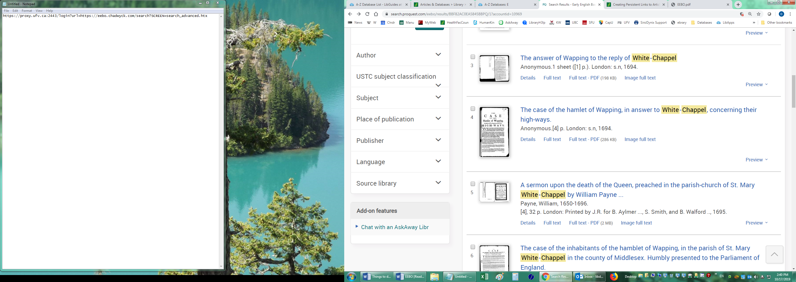

1. Scroll down the details to the Document URL and copy.

Document U R L with link.

The persistent link will look like this:

<https://www.proquest.com/eebo/books/case-hamlet-wapping-answer-white-chappel/docview/2248539740/sem-2?accountid=10969>

**Please note** that this URL **does** include the UFV Library proxy server prefix, which is essential to providing off-campus access to the stable link.