|  |  |
| --- | --- |
| UFV_subbrand_Library | Creation of Persistent Links  with a  Uniform Resource Locator (URL) |

Persistent links direct students to specific full-text journal documents found in our research databases. These links are stable, and can be accessed from both on and off campus. These links could be used for e-reserves, electronic reading lists or incorporating into Brightspace and other online course resources.

1. Find the url link you want to use and copy it.

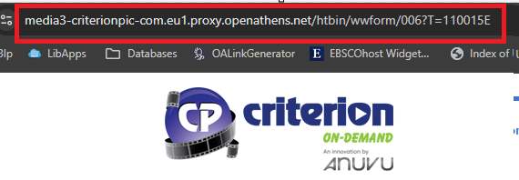

E.g. <https://media3-criterionpic-com.eu1.proxy.openathens.net/htbin/wwform/006?T=110015E>

1. If you see proxy.openathens.net in the URL, you do not need to modify the link at all. You just need to tell your students they may have to login by clicking on the link, searching by institution using Fraser and logging in using their MyClass username and password.

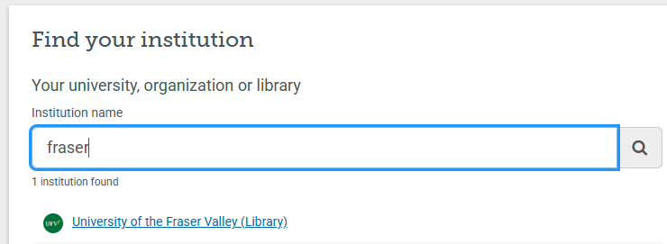

1. If you do not see proxy.openathens.net in the URL, you need to add our OpenAthens redirector <https://go.openathens.net/redirector/ufv.ca?url=> to the beginning.

https://go.openathens.net/redirector/ufv.ca?url=https://muse.jhu.edu/pub/46/article/442236