|  |  |
| --- | --- |
| UFV_subbrand_Library | Creation of Persistent Links  **ProQuest Ebook Central** |

Persistent links direct students to specific full-text journal documents found in our research databases. These links are stable, and can be accessed from both on and off campus. These links could be used for e-reserves, electronic reading lists or incorporating into Brightspace and other online course resources.

1. Choose the book that you want to link to. Copy the URL from the address bar.

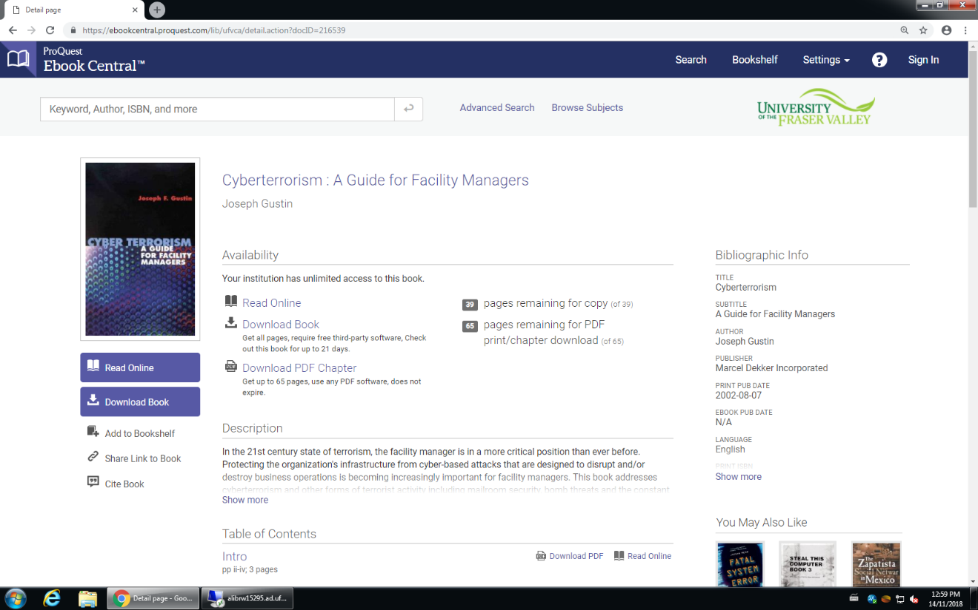

The persistent link will look like this: <https://ebookcentral.proquest.com/lib/ufvca/detail.action?docID=216539>

This link has a unique identifier for UFV so no prefix needs to be added.