|  |  |
| --- | --- |
| UFV_subbrand_Library | Creation of Persistent Links  **ProQuest Databases** |

Persistent links direct students to specific full-text journal documents found in our research databases. These links are stable, and can be accessed from both on and off campus. These links could be used for e-reserves, electronic reading lists or incorporating into Brightspace and other online course resources.

1. From the results list, click on abstract/details to view your chosen article.

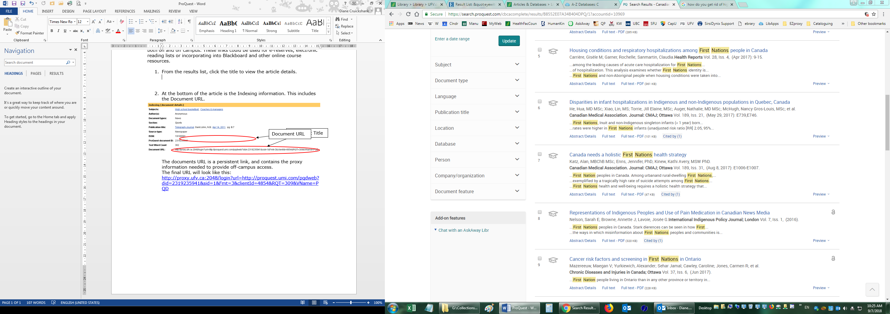

1. Near the bottom of the indexing information is the **Document URL**.



The document URL contains the proxy information needed to provide off-campus access. This will be your persistent link.

The final URL will look like this:

<https://www.proquest.com/scholarly-journals/canada-needs-holistic-first-nations-health/docview/1930066225/se-2>