|  |  |
| --- | --- |
| UFV_subbrand_Library | Creation of Persistent Links  **MathSciNet** |

Persistent links direct students to specific full-text journal documents found in our research databases. These links are stable, and can be accessed from both on and off campus. These links could be used for e-reserves, electronic reading lists or incorporating into Blackboard and other online course resources.

1. From the results list, click on the document number to view the full article details.

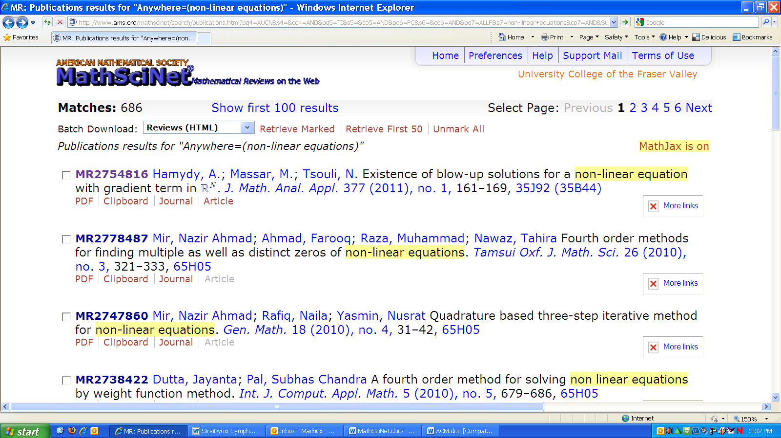

Article details

1. Click on Make Link. The URL in the address bar will change. Copy the new URL

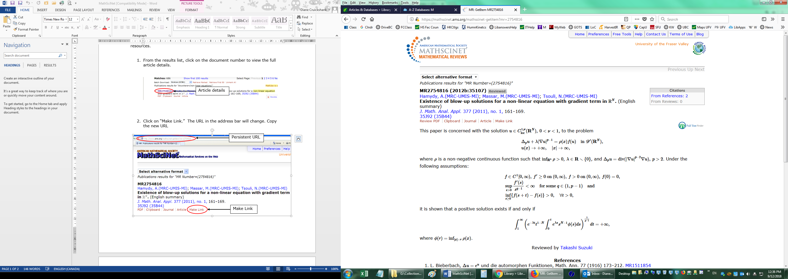

Persistent URL

Make Link

Make Link

The persistent link will look like this:

<https://mathscinet.ams.org/mathscinet-getitem?mr=2754816>

**Please note** that this URL does not include the UFV Library proxy

server prefix, which is essential to providing off-campus access to the stable link.

1. To access the article off campus you need to add the following prefix to the existing url:

<https://proxy.ufv.ca:2443/login?url=>

1. The finished URL will look like this:

<https://proxy.ufv.ca:2443/login?url=https://mathscinet.ams.org/mathscinet-getitem?mr=2754816>