|  |  |
| --- | --- |
| UFV_subbrand_Library | Creation of Persistent Links  **JSTOR** |

Persistent links direct students to specific full-text journal documents found in our research databases. These links are stable, and can be accessed from both on and off campus. These links could be used for e-reserves, electronic reading lists or incorporating into Brightspace and other online course resources.

1. **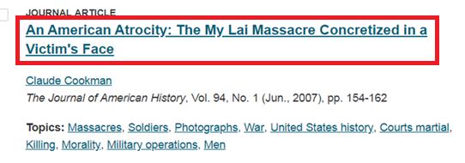**From the results list, click on the title of the article.
2. 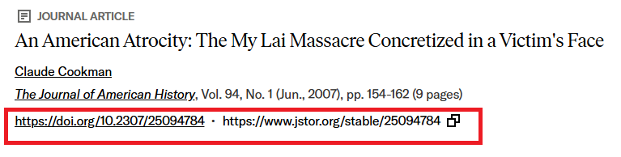You will see the DOI or the JSTOR stable link. Choose your preferred link.

**Please note** that this URL doesn’t include the UFV Library OpenAthens prefix, which is essential to providing off-campus access to the stable link.

1. Add our Open Athens redirector to the front of either the doi or the JSTOR stable link: <https://go.openathens.net/redirector/ufv.ca?url=>

<https://go.openathens.net/redirector/ufv.ca?url=https://www.jstor.org/stable/25094784>