|  |  |
| --- | --- |
| UFV_subbrand_Library | Creation of Persistent Links  **Gale Databases** |

Persistent links direct students to specific full-text journal documents found in our research databases. These links are stable, and can be accessed from both on and off campus. These links could be used for e-reserves, electronic reading lists or incorporating into Brightspace and other online course resources.

1. Find the item you want to link to. Click on “get link”.

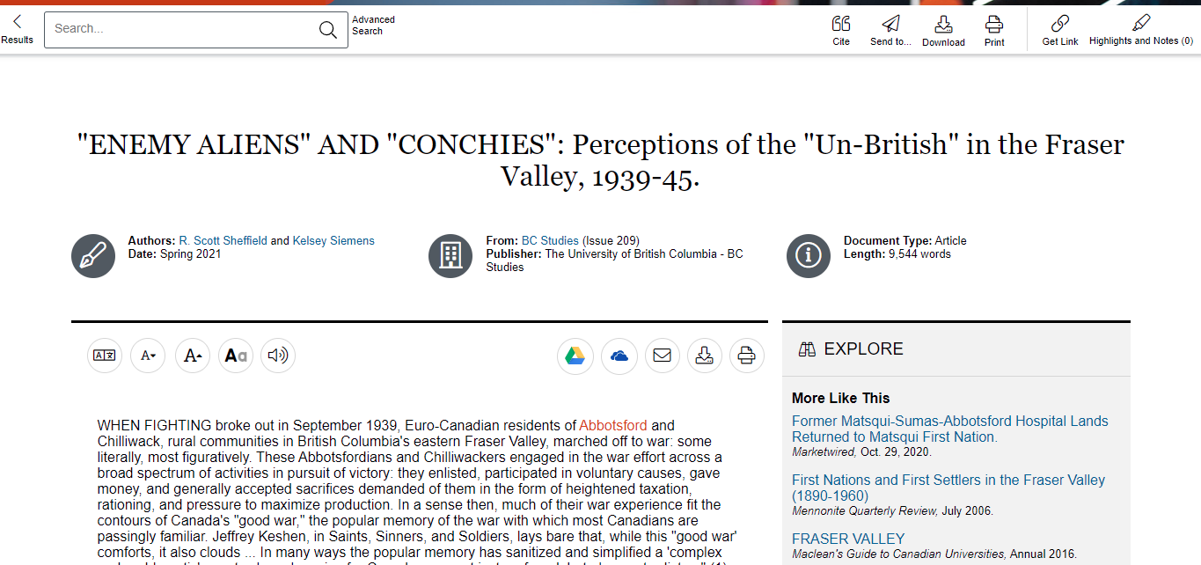

1. 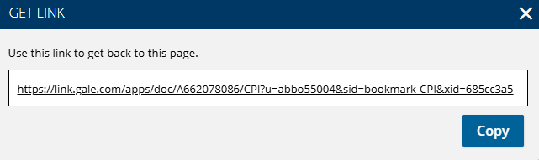A pop-up window will appear. Copy link.

The persistent link will look like this:

<https://link.gale.com/apps/doc/A662078086/AONE?u=abbo55004&sid=bookmark-AONE&xid=dfb64c55>

**Please note** that this URL will redirect to our login page anyway for easy off campus access.