|  |  |
| --- | --- |
| UFV_subbrand_Library | Creation of Persistent Links  **Films on Demand** |

Persistent links direct students to specific full-text journal documents found in our research databases. These links are stable, and can be accessed from both on and off campus. These links could be used for e-reserves, electronic reading lists or incorporating into Brightspace and other online course resources.

1. From either the results list or



Share

the main video screen, click on Share.

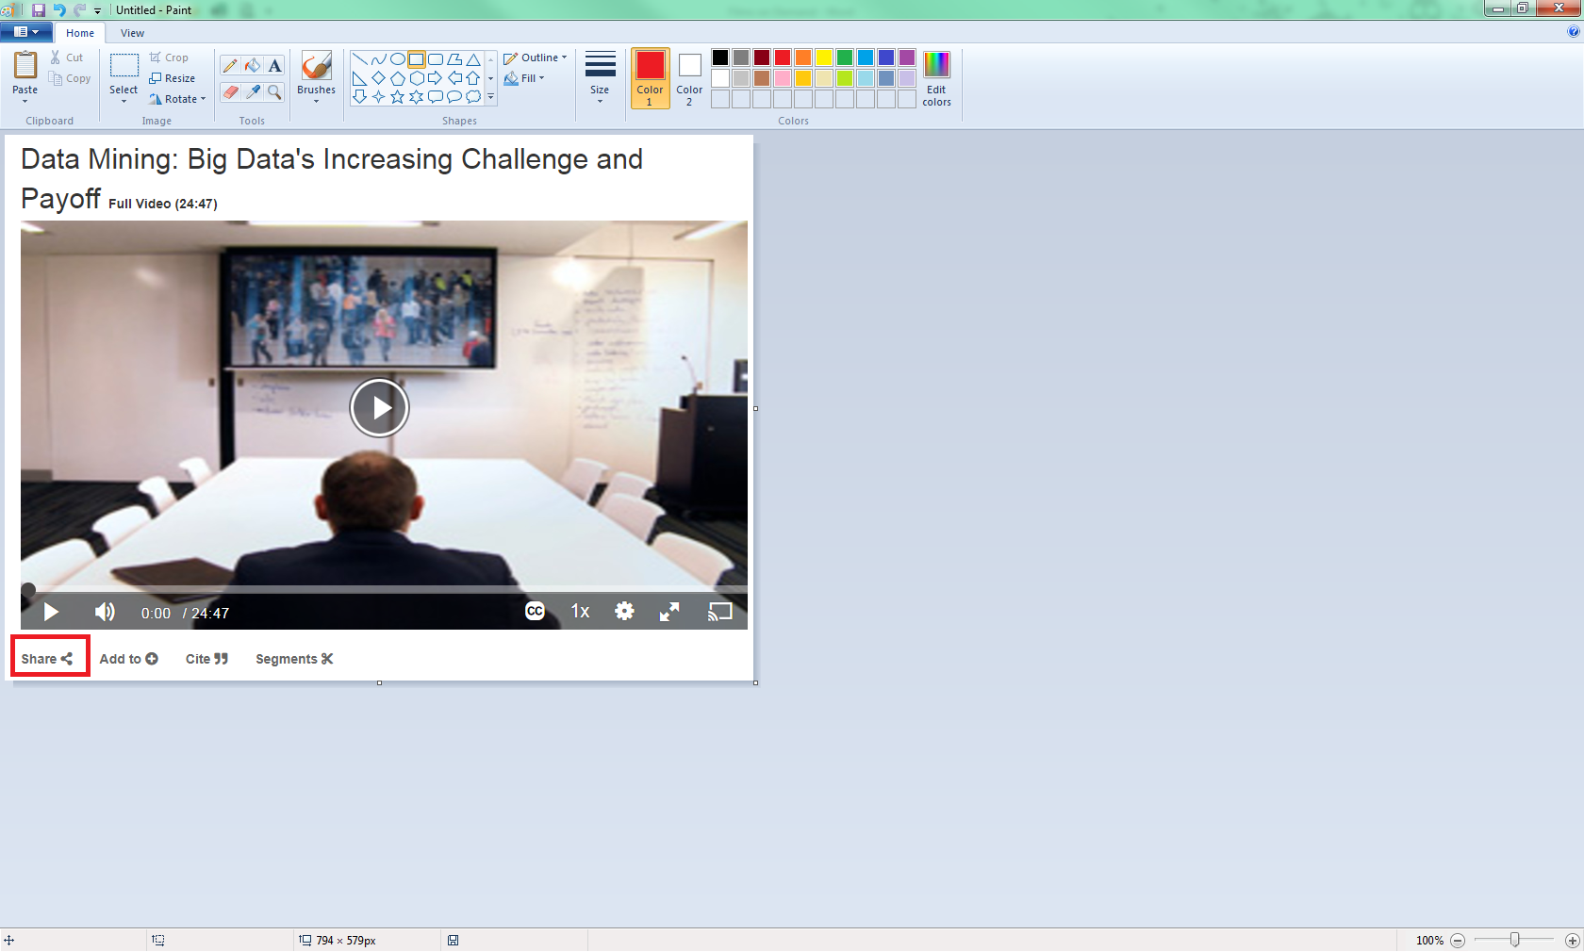

1. A pop-up box will open. Choose Embed Link.

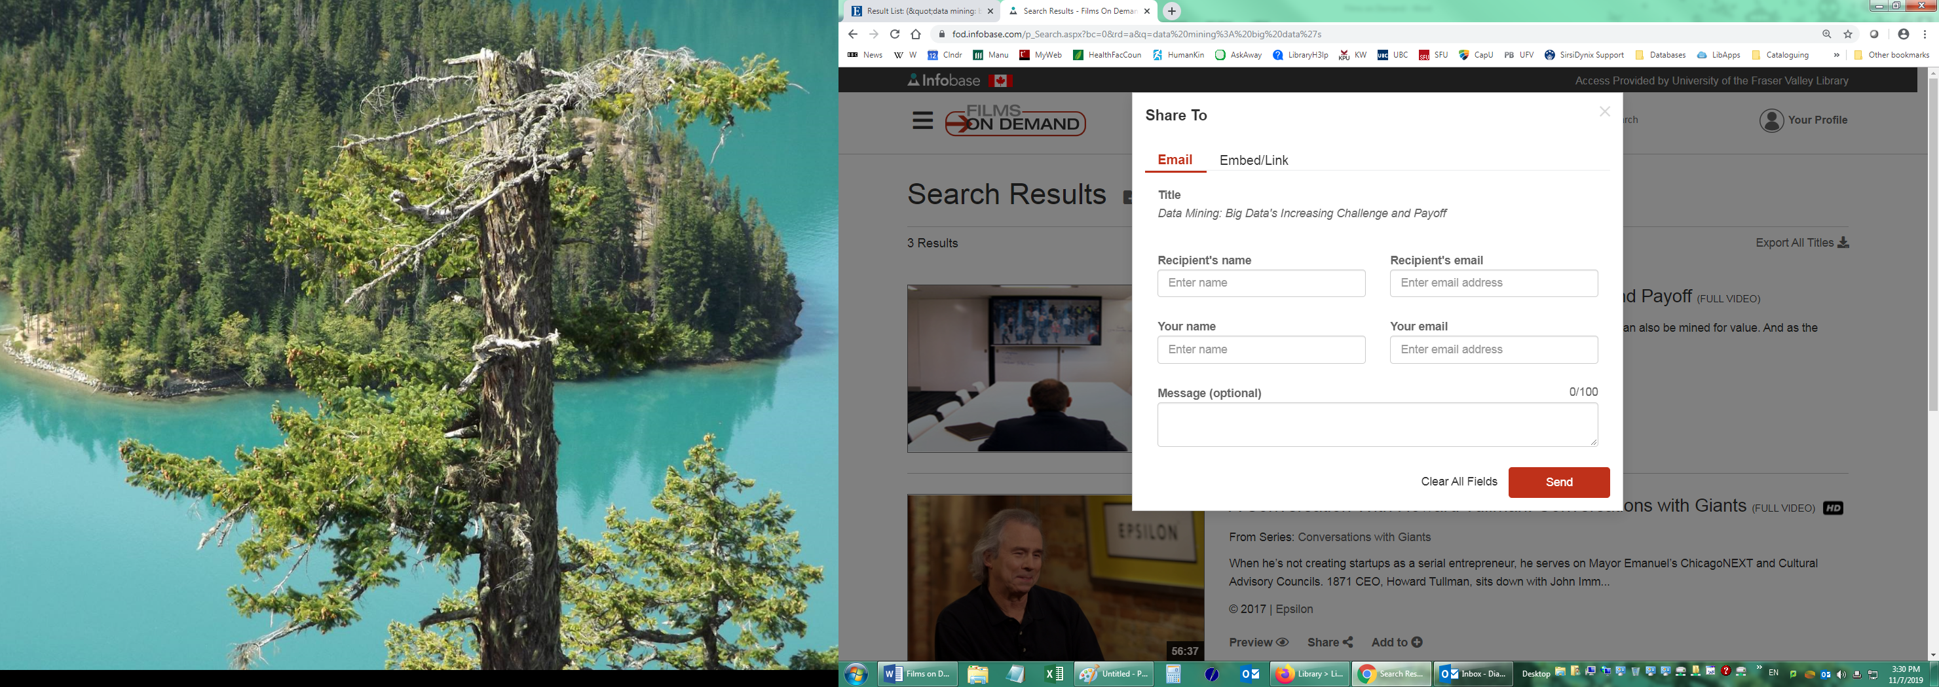

1. Copy the Record URL and the Persistent Link will look like this:

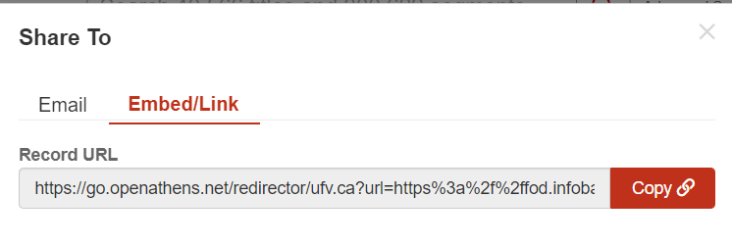<https://go.openathens.net/redirector/ufv.ca?url=https%3a%2f%2ffod.infobase.com%2fPortalPlaylists.aspx%3fwID%3d79284%26xtid%3d47487>