|  |  |
| --- | --- |
| UFV_subbrand_Library | Creation of Persistent Links  **EBSCOhost Databases** |

Persistent links direct students to specific full-text journal documents found in our research databases. These links are stable, and can be accessed both on and off campus. These links could be used for e-reserves, electronic reading lists or incorporating into Brightspace and other online course resources.

1. 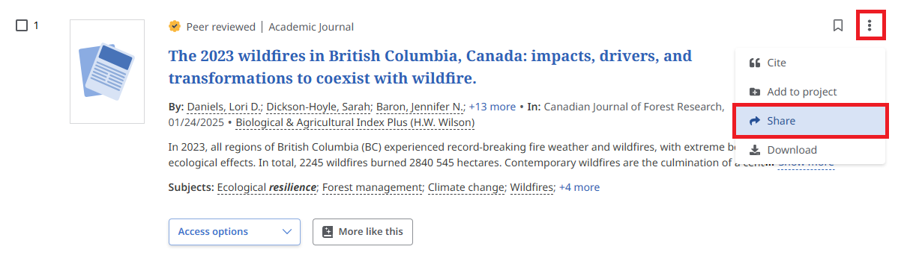From the results list, click on the three dots and select share.

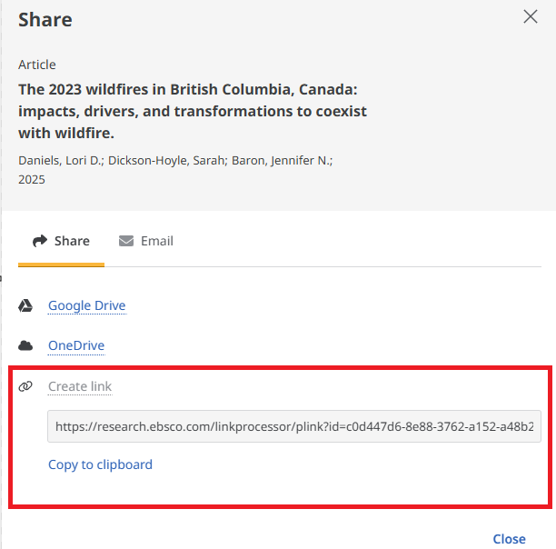

1. You have various options to choose about how to share but the create link is recommended.

Copy to clipboard and add the link to your reading list, Brightspace or wherever you want.