|  |  |
| --- | --- |
| UFV_subbrand_Library | Creation of Persistent Links  **EBM Reviews** |

Persistent links direct students to specific full-text journal documents found in our research databases. These links are stable, and can be accessed from both on and off campus. These links could be used for e-reserves, electronic reading lists or incorporating into Brightspace and other online course resources.

1. From the results list, click on the EBM Full Text.

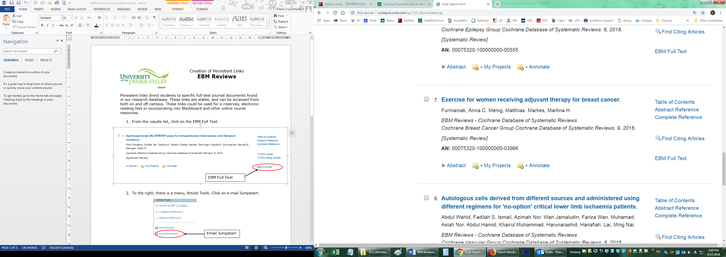

1. **To the right, there is a menu, Tools. Click on e-mail Jumpstart:**

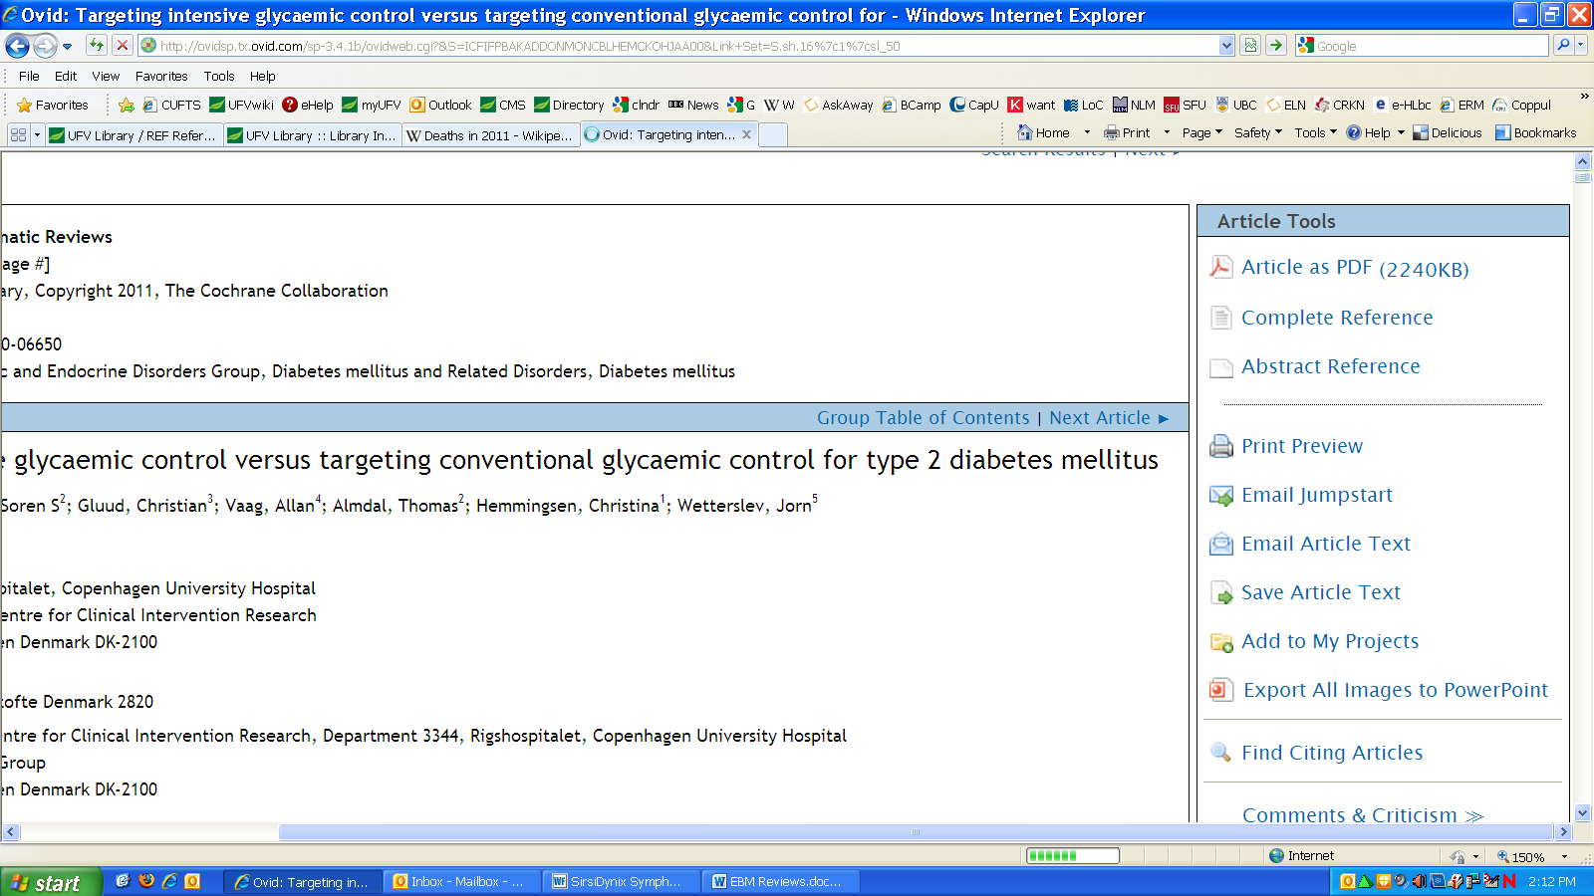

Email Jumpstart

1. **A pop-up box will open. Copy the Jumpstart URL**

**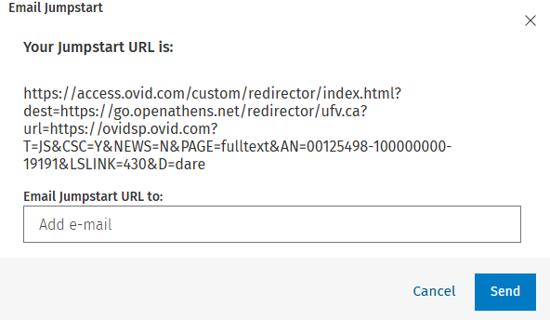**

The persistent link will look like this:

<https://access.ovid.com/custom/redirector/index.html?dest=https://go.openathens.net/redirector/ufv.ca?url=https://ovidsp.ovid.com?T=JS&CSC=Y&NEWS=N&PAGE=fulltext&AN=00125498-100000000-19191&LSLINK=430&D=dare>

**Please note** that this URL does include the UFV Library proxy server prefix, which is essential to providing off-campus access to the stable link.