|  |  |
| --- | --- |
| UFV_subbrand_Library | Creation of Persistent Links  **Docuseek Canadian Collection** |

Persistent links direct students to specific full-text journal documents found in our research databases. These links are stable, and can be accessed from both on and off campus. These links could be used for e-reserves, electronic reading lists or incorporating into Brightspace and other online course resources.

1. Go to Docuseek and click on My Movies.



1. Select the movie you want to link to either by clicking on the link or by just hitting link to/embed:



OR

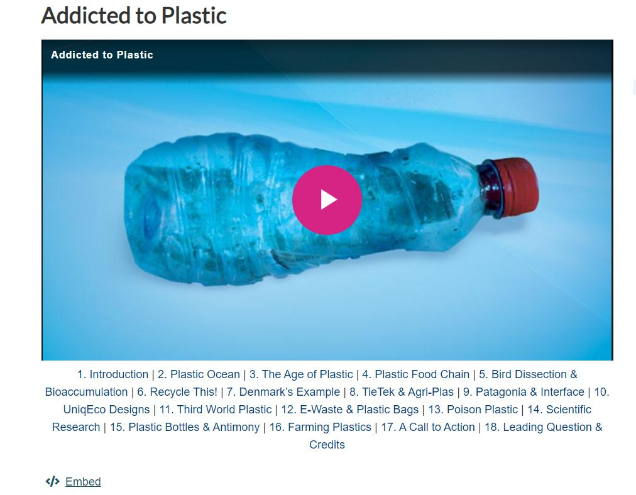

1. A pop-up box will open. Choose Permanent Link.

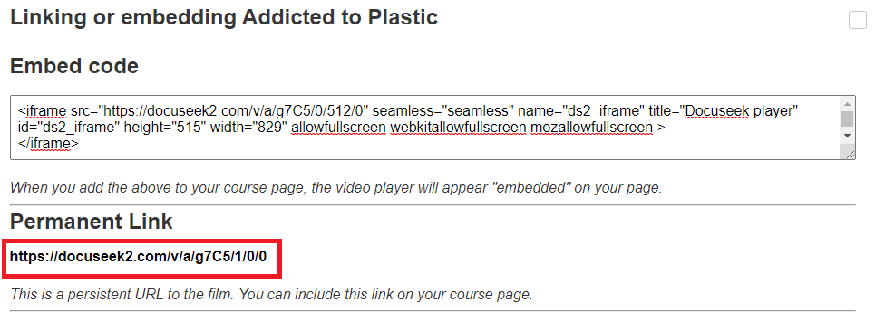

1. Go to our [OpenAthens Link Generator](https://go.openathens.net/generate/ufv.ca/80150666)  and paste in the link. Hit copy.
2. The Persistent Link will look like this:

<https://go.openathens.net/redirector/ufv.ca?url=https%3A%2F%2Fdocuseek2.com%2Fv%2Fa%2Fg7C5%2F1%2F0%2F0>