|  |  |
| --- | --- |
| UFV_subbrand_Library | Creation of Persistent Links  **Digital Theatre +** |

Persistent links direct students to specific full-text journal documents found in our research databases. These links are stable, and can be accessed from both on and off campus. These links could be used for e-reserves, electronic reading lists or incorporating into Brightspace and other online course resources.

1. 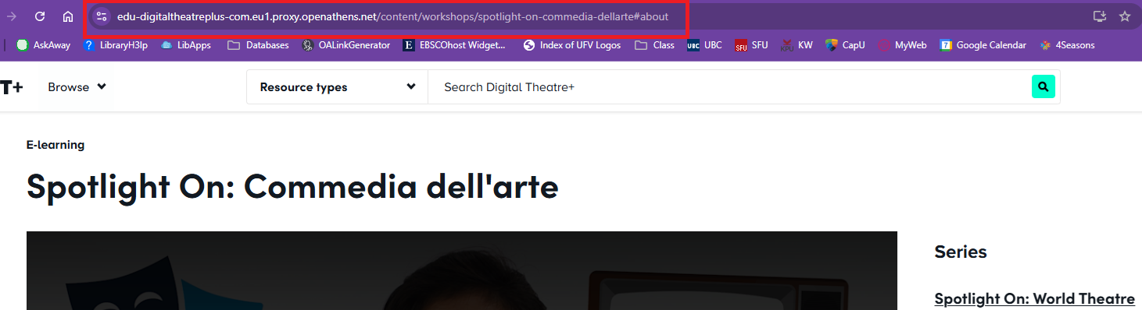Select the item you want to link to and copy the URL link in the address bar.

The link will look something like this: <https://edu-digitaltheatreplus-com.eu1.proxy.openathens.net/content/workshops/spotlight-on-commedia-dellarte#about>

The link already has proxy information that helps student login on or off campus.

1. When your students click on the link, they may be asked to find their institution. Search Fraser. Click on the link at the bottom, sign in (if needed) and the video will open.

