Creation of Persistent Links



**Curio**

Persistent links direct students to specific full-text journal documents found in our research databases. These links are stable, and can be accessed from both on and off campus. These links could be used for e-reserves, electronic reading lists or incorporating into Brightspace and other online course resources.

1. Choose the video that you want to link to. Click on Permalink.

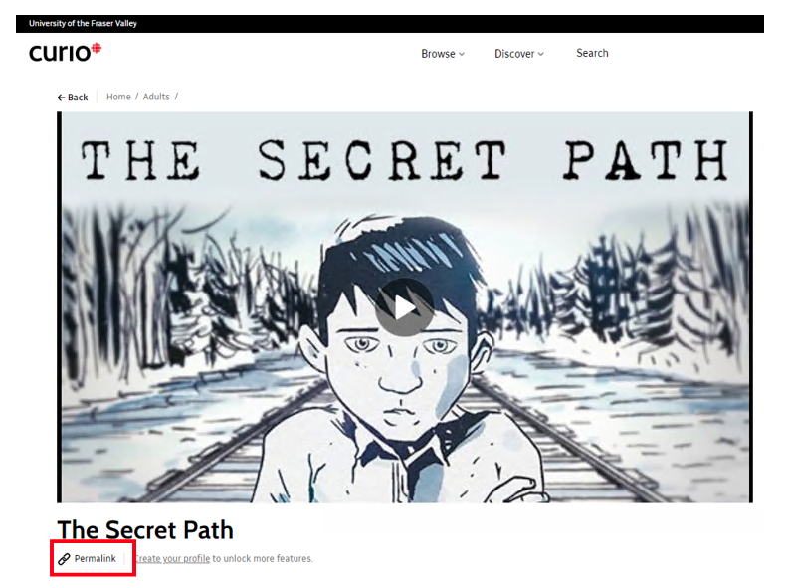

1. A pop-up box will open. Copy the link.

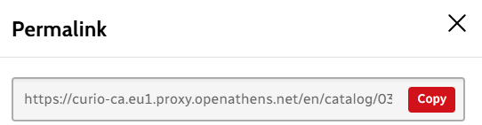

The persistent link will look like this: <https://curio-ca.eu1.proxy.openathens.net/en/catalog/0345f056-82a3-43d4-be7d-48c7cb76a299>

1. When your students click on the link, they may be asked to find their institution. Search Fraser. Click on the link at the bottom, sign in (if needed) and the video will open.

