|  |  |
| --- | --- |
|  | Creation of Persistent Links  **Criterion on Demand** |

Persistent links direct students to specific full-text journal documents found in our research databases. These links are stable, and can be accessed from both on and off campus. These links could be used for e-reserves, electronic reading lists or incorporating into Brightspace and other online course resources.

1. 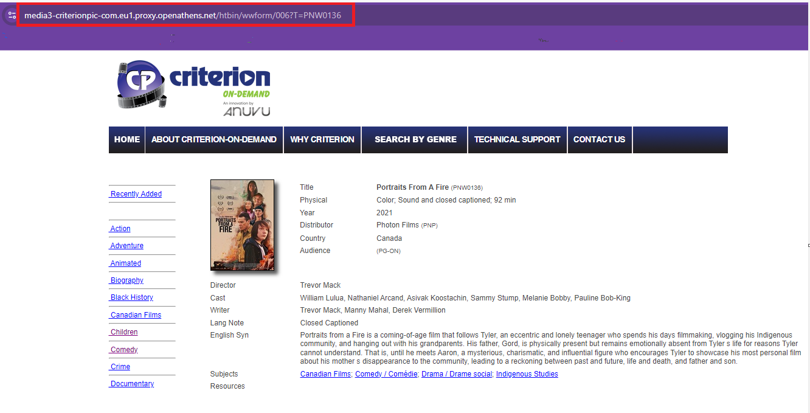Choose your video/segment and copy the url.
2. The URL will look something like this: <https://media3-criterionpic-com.eu1.proxy.openathens.net/htbin/wwform/006?T=PNW0136>

This link works on and off campus but your students will have to “Find your institution”

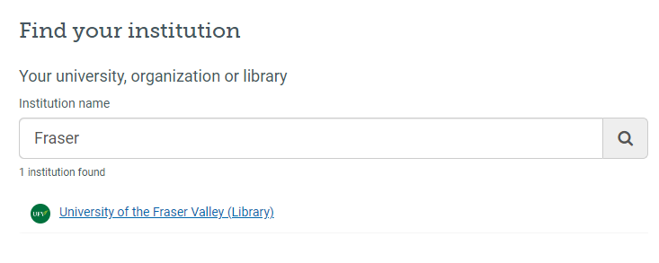

1. If you want to save your students a step about choosing the institution, then you need to do some steps first.
2. Replace the “**–**“ with a period. <https://media3.criterionpic.com>
3. And delete this: **.eu1.proxy.openathens.net.**
4. The URL should now look like this: <https://media3.criterionpic.com/htbin/wwform/006?T=PNW0136>
5. Put this URL in our [OpenAthens Link generator](https://go.openathens.net/generate/ufv.ca/80150666). Put your corrected URL in the box (<https://media3.criterionpic.com/htbin/wwform/006?T=PNW0136>) and the generator will generate a link. Copy.
6. The finished URL will look like this: <https://go.openathens.net/redirector/ufv.ca?url=https%3A%2F%2Fmedia3.criterionpic.com%2Fhtbin%2Fwwform%2F006%3FT%3DPNW0136>