|  |  |
| --- | --- |
| UFV_subbrand_Library | Creation of Persistent Links  **Chicago Manual of**  **Style Online** |

Persistent links direct students to specific full-text journal documents found in our research databases. These links are stable, and can be accessed from both on and off campus. These links could be used for e-reserves, electronic reading lists or incorporating into Brightspace and other online course resources.

1. 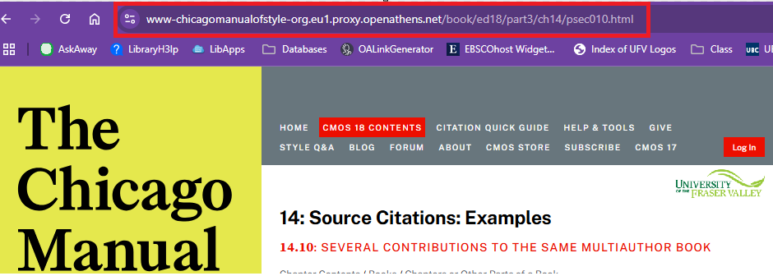Find the entry you want to link to. Copy the URL from the address bar

The persistent link will look like this:

<https://www-chicagomanualofstyle-org.eu1.proxy.openathens.net/book/ed18/part3/ch14/psec010.html>

1. If you see proxy.openathens.net in the URL you do not need to modify the link at all. You just need to tell your students to click on the link, search by institution using Fraser and login using their MyClass username and password.

