|  |  |
| --- | --- |
| UFV_subbrand_Library | Creation of Persistent Links  **Canada Commons** |

Persistent links direct students to specific full-text journal documents found in our research databases. These links are stable, and can be accessed from both on and off campus. These links could be used for e-reserves, electronic reading lists or incorporating into Brightspace and other online course resources.

1. Find the document you want to link to.

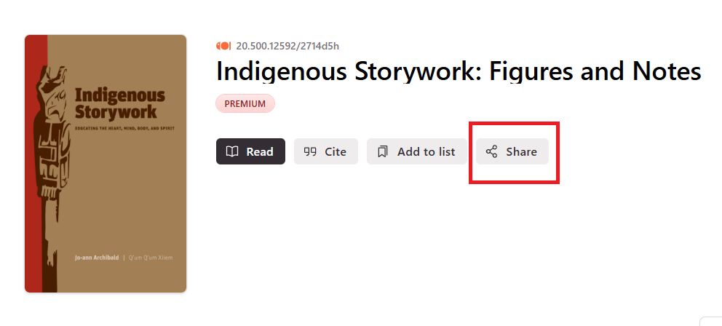

1. Copy link.

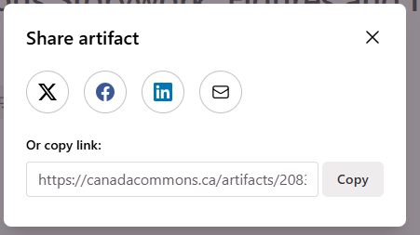

The link will look something like this:

**https://canadacommons.ca/artifacts/20834548/indigenous-storywork/21734998/**

**Please note** that this URL does not include the UFV Library OpenAthens redirector, which is essential to providing off-campus access to the stable link.

1. To access the article off campus you need to add the following prefix to the existing url:

<https://go.openathens.net/redirector/ufv.ca?url=>

1. The finished URL will look like this:

<https://go.openathens.net/redirector/ufv.ca?url=https://canadacommons.ca/artifacts/20834548/indigenous-storywork/21734998/>