|  |  |
| --- | --- |
| UFV_subbrand_Library | Creation of Persistent Links  **CPA Standards &**  **Guidance Collection** |

Persistent links direct students to specific full-text journal documents found in our research databases. These links are stable, and can be accessed from both on and off campus. These links could be used for electronic reading lists or incorporating into Brightspace and other online course resources.

1. Select the document you want to link to and click on the Share or Link icon.

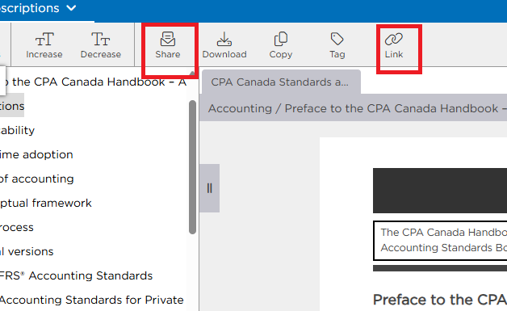

1. Copy the URL.

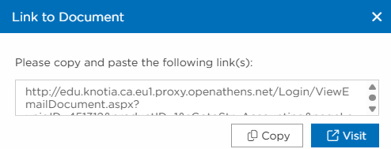

The persistent link will look like this:

<http://edu.knotia.ca.eu1.proxy.openathens.net/Login/ViewEmailDocument.aspx?uniqID=451310&productID=1&sGotoStr=acchigh+56&pageLanguage=en>

1. When your students click on the link, they may be asked to find their institution. Search Fraser. Click on the link at the bottom, sign in (if needed) and the video will open.

