|  |  |
| --- | --- |
|  | Creation of Persistent Links  **JSTOR images** |

Persistent links direct students to specific full-text journal documents found in our research databases. These links are stable, and can be accessed from both on and off campus. These links could be used for e-reserves, electronic reading lists or incorporating into Brightspace and other online course resources.

1. Go to [JSTOR](https://libguides.ufv.ca/databases/jstor). Click on Browse and go to Images from the drop-down menu. Choose your desired image.

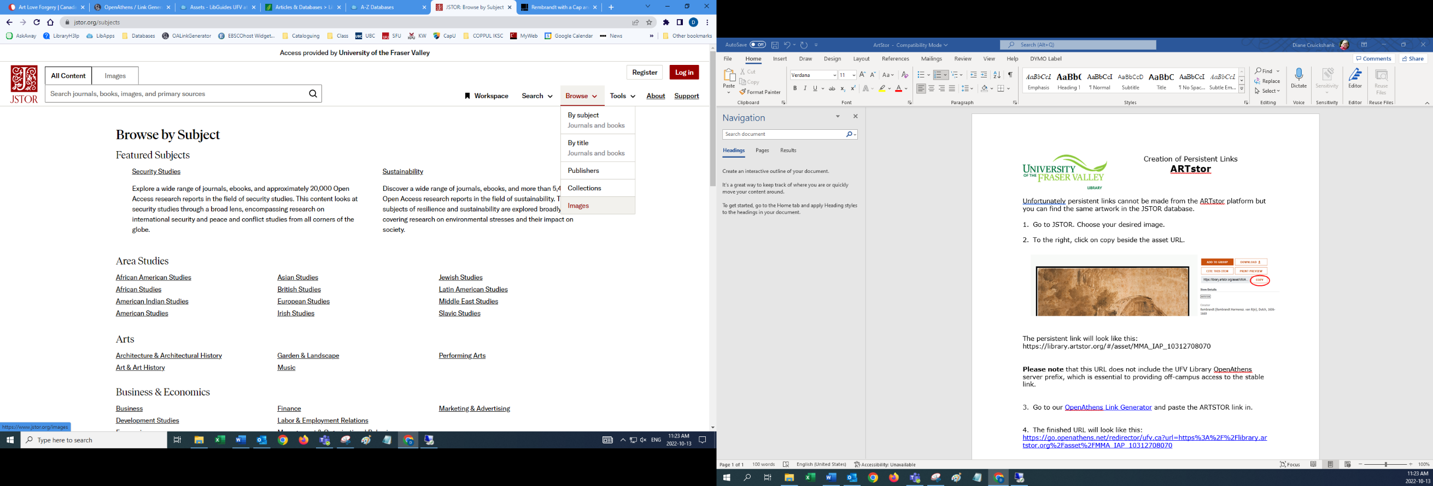

1. 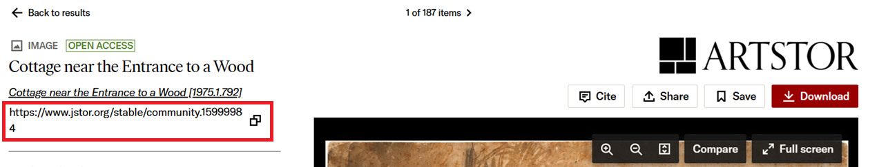To the left, copy the URL.

**Please note** that this URL does not include the UFV Library OpenAthens server prefix, which is essential to providing off-campus access to the stable link.

1. Go to our [OpenAthens Link Generator](https://go.openathens.net/generate/ufv.ca/80150666) and paste the link. Hit Copy for the permalink.

1. The finished URL will look like this:

<https://go.openathens.net/redirector/ufv.ca?url=https%3A%2F%2Fwww.jstor.org%2Fstable%2Fcommunity.15999984>

1. Just a reminder that JSTOR asks you to create an account. You do not need to. All you need to do is X (close) out of the window and you will see your artwork.

