|  |  |
| --- | --- |
| UFV_subbrand_Library | Creation of Persistent Links  **Annual Reviews** |

Persistent links direct students to specific full-text journal documents found in our research databases. These links are stable, and can be accessed from both on and off campus. These links could be used for e-reserves, electronic reading lists or incorporating into Brightspace and other online course resources.

1. Find the article you want to link to. Copy the doi or use the share icon

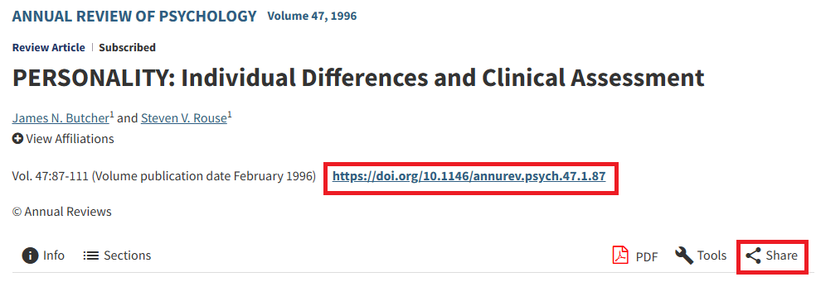

The link will look like this:

<https://doi.org/10.1146/annurev.psych.47.1.87>

or this:

<https://www.annualreviews.org/content/journals/10.1146/annurev.psych.47.1.87?utm_campaign=shareaholic&utm_medium=copy_link&utm_source=bookmark>

**Please note** that this URL does not include the UFV Library Open Athens redirector, which is essential to providing off-campus access to the stable link.

1. To access the article off campus you need to add the following prefix to the existing url: <https://go.openathens.net/redirector/ufv.ca?url=>
2. The finished URL will look like this:

<https://go.openathens.net/redirector/ufv.ca?url=https://doi.org/10.1146/annurev.psych.47.1.87>