|  |  |
| --- | --- |
| UFV_subbrand_Library | Creation of Persistent Links  **American History in Video &**  **Theater in Video** |

Persistent links direct students to specific full-text documents found in our research databases. These links are stable, and can be accessed from both on and off campus. These links could be used for e-reserves, electronic reading lists or incorporating into Brightspace and other online course resources.

1. Select the video you want to link to and click on share:

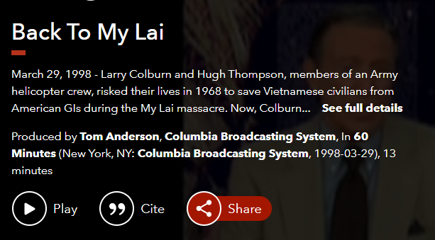

1. At pop up box will open. Click on Copy permalink.

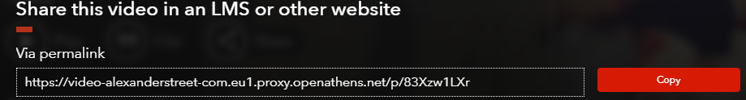

The permalink will look like this:

<https://video-alexanderstreet-com.eu1.proxy.openathens.net/p/83Xzw1LXr>

1. When your students click on the link they may be asked to find their institution. Search Fraser. Click on the link at the bottom, sign in (if needed) and the video will open.

