|  |  |
| --- | --- |
|  | Creation of Persistent Links  **Adam Matthew**  **Digital Collection** |

Persistent links direct students to specific full-text journal documents found in our research databases. These links are stable and can be accessed from both on and off campus. These links could be used for e-reserves, electronic reading lists or incorporating into Brightspace and other online course resources.

1. Each digital collection has a slightly different layout, but the creation of persistent link is the same.
2. Choose a content tab.

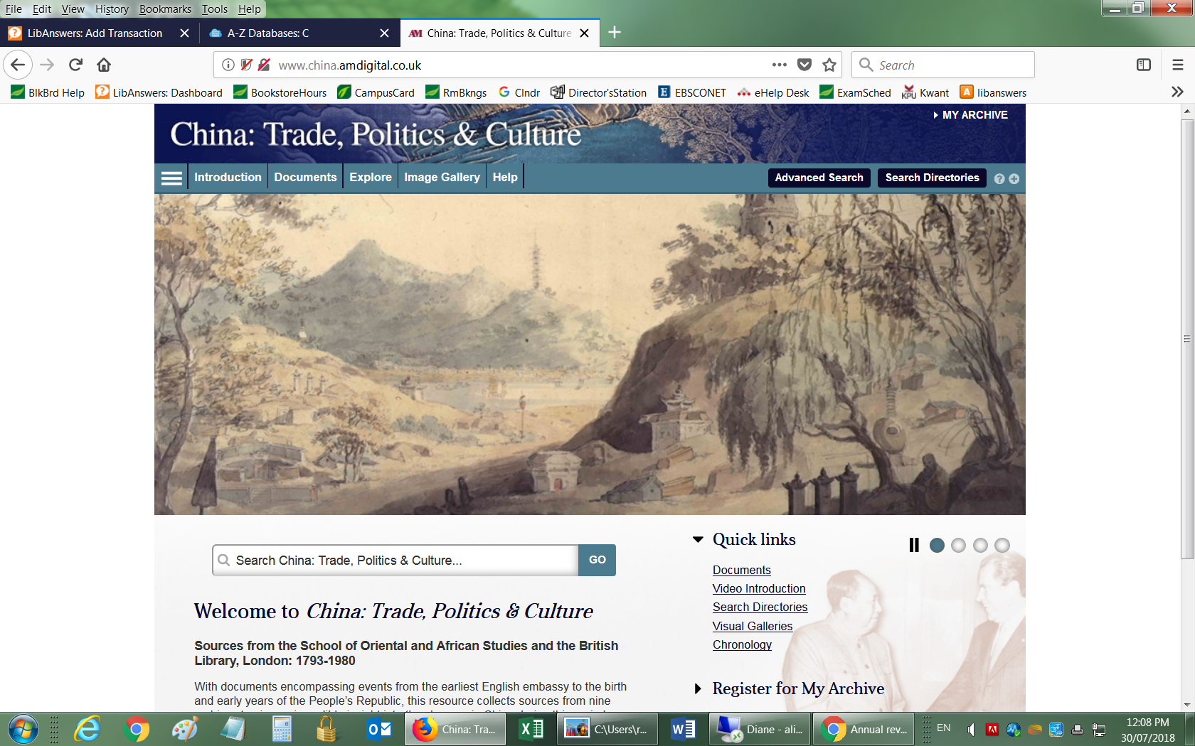

1. Select the item you want to link to and copy the url.

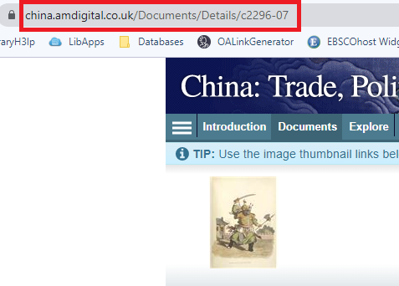

The link will look like this: <https://www.china.amdigital.co.uk/Documents/Details/c2296-07>

**Please note** that this URL does not include the UFV Library OpenAthens server prefix, which is essential to providing off-campus access to the stable link.

1. Go to our [OpenAthens Link Generator](https://go.openathens.net/generate/ufv.ca/80150666) and paste in the link. Hit Copy.
2. The finished URL will look like this:

<https://go.openathens.net/redirector/ufv.ca?url=https%3A%2F%2Fwww.china.amdigital.co.uk%2FDocuments%2FDetails%2Fc2296-07>